

**Ain Shams University**

**Faculty of Engineering**

**Computer and Systems Engineering**

Database Systems Project



**Program: Specialized Programs**

***Course Code: CSE 333s***

***Course Name: Database Systems***

***Team Members:***

**Omar Mohamed Diaaeldin Ibrahim 1802932**

**Ahmed Magdy Fahmy Mohamed 1805862**

**Ahmed Abdallah Mansour Abdel Lateif 1809252**

**Ahmed Mohamed Ahmed Sayed 1804904**

***Presented To***

**Dr. Hoda Korashy Mohamed**

**Ain Shams University**

**Faculty of Engineering**

**Spring Semester – 2022**



**Medicine Factory Database System**

**Table of content**

1.0 Introduction: 4

2.0 Important Data and Reports: 4

3.0 Assumptions: 5

4.0 EER Diagram: 5

**4.1 Hand-Written:(Attached File “Database Hand.pdf” where full image is full) 6**

**4.2 Using Tool (ERD Plus):(Attached File “Database ERD PLus.pdf” where full image is full) 7**

5.0 Database Schema (Relational Data Model): 8

**5.1 Hand-Written: 8**

**5.2 Using Tool (ERD Plus): 11**

6.0 SQL Code (Creation of Tables & Sample Operations): 13

7.0 Implementation 28

**7.1 Using ERD tool 28**

**7.2 Using MySQL WorkBench tool 40**

# Introduction:

We are going to design a database for medicine factory, which records the following: Employees types such as manager, driver, salesman, chemist, …. etc. Employee have some attributes which are unique ID, full name, birthdate, bonus/deduction, working hours, gender, phone number, salary, address and hiring date. In addition, each employee works for one department and each department is managed by only one manager. Each department contains more than one employee and has attributes unique number, name and number of employees. Manager manage only one department and may have several dependents and have attribute experience. Dependent has attributes unique ID, full name, gender, salary, birthdate, bonus/deduction, working hours, hiring date and phone number.

The factory offers transportation facilities for each employee and it vary according to the employee’s level. For managers, they can has a car with driver but some of the use their private car. Car has attribute model. On the other hand, there are buses available for chemist and salesman. To make it clear, the factory has three types of vehicles which are cars, buses and trucks. Vehicle has attributes unique number, destination and maintains date and there is a driver for each vehicle. Driver is allowed to drive only one vehicle and has attribute license. Truck has attribute truckload while each bus has attribute number of passengers.

Salesman has attribute target which is specific quantity of medicine need to sell. Each medicine has attributes unique ID, name, quantity, price, description, manufacture date, usage duration and expiry date. Moreover, medicine is either liquid or tablet. Each liquid has attribute volume while each tablet has attribute number of tablets. The factory clients are factories, hospital and pharmacies. Client has attributes unique ID, name, address and phone number. When a client buy medicine there are some data need to be stored which are receipt, receipt date, quantity and discount if there is. Factory has attribute factory type and pharmacy has attribute reach while hospital has attribute reputation.

Chemist combined the raw materials to produce the medicine and has attribute lab access which is the number of the lab that the chemist working on it. Part of the raw materials are manufactured while other part is supplied from suppliers and each raw material has attributes unique name, description and quantity. Manufactured raw materials has attribute manufacture date while the bought ones have price. The supplier has attributes unique name, phone number and address. When supplying there are some data need to be stored which are receipt, receipt date and quantity.

# Important Data and Reports:

Consider the relational schema mentioned later in this project,

Reports: -

* For each department, whose average employee salary is more than $5000, retrieve the department name and the number of employees working for this department.
* Retrieve the full names of the employees who have dependents with salary more than $7000
* Retrieve the list of raw materials and the suppliers’ names suppling them, ordered by the raw materials purchased price.
* Insert a new client, <’CL4390’, ‘Mark’, ‘01958873251’>
* Update the price of medicine ’Panadol’ to 7.50
* Delete the record for salesman whose ID is ‘SM410’
* Create view table with name DEPT-EMP that count the total number of employees in each department.
* Retrieve all the clients names whose address is in Alexandria, where the value of the address attribute must contain the substring ‘Alexandria’ in it.
* Show the effect of giving all the employees who work more than 9 working hours a 15% raise
* Retrieve the driver license who drives a car of model ‘Benz’ and the manager having this car have an experience more than 5 years
* Retrieve the list of clients’ names ordered alphabetically.

# Assumptions:

1. Not all the cars for the managers. there are some cars used in other things
2. Each driver drives only one car and each car is driven by only one driver
3. Salesmen can use only one bus
4. Chemists can take only one bus
5. Each bus has several salesmen and chemists
6. Each client can buy more than one medicine and types of medicines are bought by more than one client
7. Each raw material is used in making more than one type of medicine and each medicine is made of more than one type of raw material
8. Each chemist combines more than one raw material and each raw martials is combined by only one chemist
9. Each supplier supply more than one raw material while raw material may be supplied by more than one supplier
10. In the database schema, entities driver and vehicle concatenated together in vehicle driver table. EmpID and VehNumber each of them is foreign key and both of them are primary key which is very special case because the EmpID must be primary key as Driver entity is inherited from Employee entity while VehNumber must be primary key as there will be foreign key in tables Bus, Truck and Car referring to it.

# EER Diagram:

## Hand-Written:(Attached File “Database Hand.pdf” where full image is full)

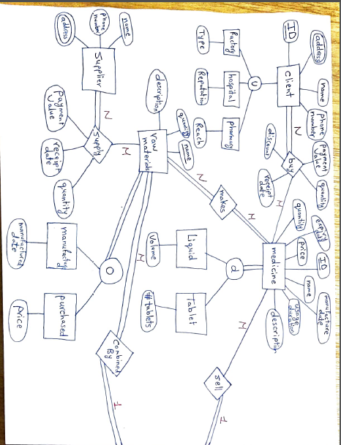

## Using Tool (ERD Plus):(Attached File “Database ERD PLus.pdf” where full image is full)

# Database Schema (Relational Data Model):

## Hand-Written:

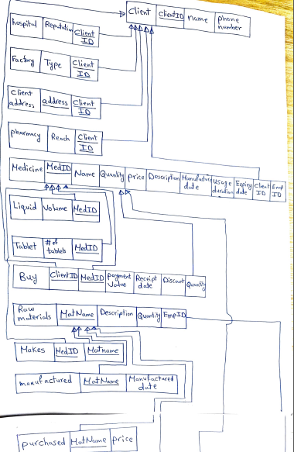

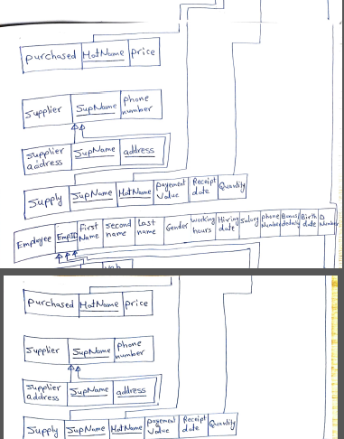

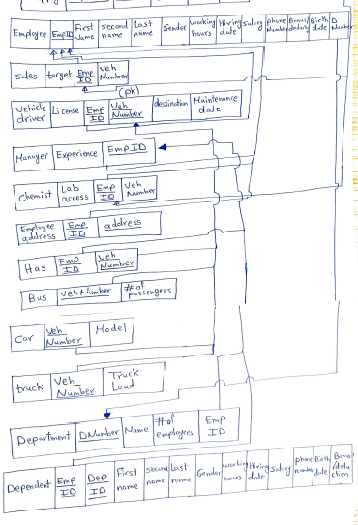

## Graphical user interface, application Description automatically generated Using Tool (ERD Plus):

# SQL Code (Creation of Tables & Sample Operations):

CREATE TABLE Client(

ClientID char(7) NOT NULL,

name char(20) NOT NULL,

phone_number char(11),

PRIMARY KEY (ClientID)

);

CREATE TABLE Hospital(

Reputation char(2),

ClientID char(7) NOT NULL,

PRIMARY KEY(ClientID),

FOREIGN KEY(ClientID) REFERENCES Client(ClientID)

ON DELETE CASCADE

ON UPDATE CASCADE

);

CREATE TABLE Factory(

Type char(10),

ClientID char(7) NOT NULL,

PRIMARY KEY(ClientID),

FOREIGN KEY(ClientID) REFERENCES Client(ClientID)

ON DELETE CASCADE

ON UPDATE CASCADE

);

CREATE TABLE Client_address(

address char(30) NOT NULL,

ClientID char(7) NOT NULL,

PRIMARY KEY(address,ClientID),

FOREIGN KEY(ClientID) REFERENCES Client(ClientID)

ON DELETE CASCADE

ON UPDATE CASCADE

);

CREATE TABLE Pharmacy(

Reach char(20) NOT NULL,

ClientID char(7) NOT NULL,

PRIMARY KEY(ClientID),

FOREIGN KEY(ClientID) REFERENCES Client(ClientID)

ON DELETE CASCADE

ON UPDATE CASCADE

);

CREATE TABLE Employee(

EmpID char(7) NOT NULL,

firstName char(13) NOT NULL,

secondName char(13),

lastName char(13) NOT NULL,

Gender char(6),

working_hours char(9),

hiringDate DATE,

Salary DECIMAL(6,2),

phoneNumber char(11),

bonus DECIMAL(3,2),

birthate DATE,

DNumber char(3),

PRIMARY KEY (EmpID)

);

CREATE TABLE Manager(

Expereience char(50) NOT NULL,

EmpID char(7) NOT NULL,

PRIMARY KEY (EmpID),

FOREIGN KEY (EmpID) REFERENCES Employee(EmpID)

ON DELETE CASCADE

ON UPDATE CASCADE

);

CREATE TABLE Department(

EmpID char(7) NOT NULL,

Name char(12) NOT NULL,

numEmployees INT,

DNumber char(3),

PRIMARY KEY (DNumber),

FOREIGN KEY (EmpID) REFERENCES Manager(EmpID)

ON DELETE CASCADE

ON UPDATE CASCADE

);

ALTER TABLE Employee ADD CONSTRAINT foreignKey

FOREIGN KEY (DNumber) REFERENCES Department(DNumber)

ON DELETE CASCADE

ON UPDATE CASCADE

;

CREATE TABLE Employee_address(

EmpID char(7) NOT NULL,

address char(30) NOT NULL,

PRIMARY KEY (EmpID, address),

FOREIGN KEY (EmpID) REFERENCES Employee(EmpID)

ON DELETE CASCADE

ON UPDATE CASCADE

);

CREATE TABLE Dependent(

EmpID char(7) NOT NULL,

DepID char(7) NOT NULL,

firstName char(10) NOT NULL,

secondName char(10),

lastName char(10) NOT NULL,

gender char(6),

working_hours char(9),

hiringDate DATE,

Salary DECIMAL(6,2),

phoneNumber char(11),

bonus DECIMAL(3,2),

birthdate DATE,

PRIMARY KEY (EmpID, DepID),

FOREIGN KEY (EmpID) REFERENCES Manager(EmpID)

ON DELETE CASCADE

ON UPDATE CASCADE

);

CREATE TABLE Driver(

License char(10) NOT NULL,

EmpID char(7) NOT NULL,

veh_number char(6) NOT NULL UNIQUE,

destination char(30),

maintenance_date DATE,

PRIMARY KEY (EmpID,veh_number),

FOREIGN KEY (EmpID) REFERENCES Employee(EmpID)

ON DELETE CASCADE

ON UPDATE CASCADE

);

CREATE TABLE Truck(

veh_number char(6) NOT NULL,

truck_load char(10),

PRIMARY KEY (veh_number),

FOREIGN KEY (veh_number) REFERENCES Driver(veh_number)

ON DELETE CASCADE

ON UPDATE CASCADE

);

CREATE TABLE Car(

veh_number char(6) NOT NULL,

model char(20),

PRIMARY KEY (veh_number),

FOREIGN KEY (veh_number) REFERENCES Driver(veh_number)

ON DELETE CASCADE

ON UPDATE CASCADE

);

CREATE TABLE Bus(

veh_number char(6) NOT NULL,

numPassengers INT,

PRIMARY KEY (veh_number),

FOREIGN KEY (veh_number) REFERENCES Driver(veh_number)

ON DELETE CASCADE

ON UPDATE CASCADE

);

CREATE TABLE Has(

EmpID char(7) NOT NULL,

veh_number char(6) NOT NULL,

PRIMARY KEY (EmpID,veh_number),

FOREIGN KEY (EmpID) REFERENCES Manager(EmpID)

ON DELETE CASCADE

ON UPDATE CASCADE,

FOREIGN KEY (veh_number) REFERENCES Car(veh_number)

ON DELETE CASCADE

ON UPDATE CASCADE

);

CREATE TABLE Salesman(

target char(10),

EmpID char(7) NOT NULL,

veh_number char(6) NOT NULL,

PRIMARY KEY (EmpID),

FOREIGN KEY(EmpID) REFERENCES Employee(EmpID)

ON DELETE CASCADE

ON UPDATE CASCADE,

FOREIGN KEY (veh_number) REFERENCES Bus(veh_number)

ON DELETE CASCADE

ON UPDATE CASCADE

);

CREATE TABLE Medicine(

MedID char(7) NOT NULL,

Name char(20) NOT NULL,

Quantity INT,

Price DECIMAL(3,2),

Description char(100),

Manufacture_date DATE,

Usage_duration char(10),

Expiry_date DATE,

EmpID char(7) NOT NULL,

PRIMARY KEY(MedID),

FOREIGN KEY(EmpID) REFERENCES Salesman(EmpID)

ON DELETE CASCADE

ON UPDATE CASCADE

);

CREATE TABLE Liquid(

Volume char(10),

MedID char(7) NOT NULL,

PRIMARY KEY(MedID),

FOREIGN KEY(MedID) REFERENCES Medicine(MedID)

ON DELETE CASCADE

ON UPDATE CASCADE

);

CREATE TABLE Tablet(

numTablets INT,

MedID char(7) NOT NULL,

PRIMARY KEY(MedID),

FOREIGN KEY(MedID) REFERENCES Medicine(MedID)

ON DELETE CASCADE

ON UPDATE CASCADE

);

CREATE TABLE Chemist(

Lab_access char(10) NOT NULL,

EmpID char(7) NOT NULL,

veh_number char(6) NOT NULL,

PRIMARY KEY (EmpID),

FOREIGN KEY (EmpID) REFERENCES Employee(EmpID)

ON DELETE CASCADE

ON UPDATE CASCADE,

FOREIGN KEY (veh_number) REFERENCES Bus(veh_number)

ON DELETE CASCADE

ON UPDATE CASCADE

);

CREATE TABLE Raw_Materials(

MatName char(20) NOT NULL UNIQUE,

Description char(100),

Quantity INT,

EmpID char(7) NOT NULL,

PRIMARY KEY(MatName),

FOREIGN KEY (EmpID) REFERENCES Chemist(EmpID)

ON DELETE CASCADE

ON UPDATE CASCADE

);

CREATE TABLE Makes(

Matname char(20) NOT NULL,

MedID char(7) NOT NULL,

PRIMARY KEY (Matname, MedID),

FOREIGN KEY(MedID) REFERENCES Medicine(MedID)

ON DELETE CASCADE

ON UPDATE CASCADE,

FOREIGN KEY(Matname) REFERENCES Raw_materials(MatName)

ON DELETE CASCADE

ON UPDATE CASCADE

);

CREATE TABLE Buy(

payment_value DECIMAL(4,2),

receipt_date DATE,

discount char(4),

quantinty INT,

ClientID char(7) NOT NULL,

MedID char(7) NOT NULL,

PRIMARY KEY (ClientID, MedID),

FOREIGN KEY(MedID) REFERENCES Medicine(MedID)

ON DELETE CASCADE

ON UPDATE CASCADE,

FOREIGN KEY(ClientID) REFERENCES Client(ClientID)

ON DELETE CASCADE

ON UPDATE CASCADE

);

CREATE TABLE Supplier(

SupName char(20) NOT NULL,

phone_number char(11),

PRIMARY KEY (SupName)

);

CREATE TABLE Supplier_address(

SupName char(20) NOT NULL,

address char(30) NOT NULL,

PRIMARY KEY (SupName,address),

FOREIGN KEY (SupName) REFERENCES Supplier(SupName)

ON DELETE CASCADE

ON UPDATE CASCADE

);

CREATE TABLE Supply(

SupName char(20) NOT NULL,

MatName char(20) NOT NULL,

payment_value DECIMAL(6,2),

receipt_date DATE,

quantity INT,

PRIMARY KEY(SupName, MatName),

FOREIGN KEY(MatName) REFERENCES Raw_Materials(MatName)

ON DELETE CASCADE

ON UPDATE CASCADE,

FOREIGN KEY(SupName) REFERENCES Supplier(SupName)

ON DELETE CASCADE

ON UPDATE CASCADE

);

CREATE TABLE Purchased(

MatName char (20) NOT NULL,

price DECIMAL (6,2),

PRIMARY KEY (MatName),

FOREIGN KEY(MatName) REFERENCES Raw_Materials(MatName)

ON DELETE CASCADE

ON UPDATE CASCADE

);

CREATE TABLE Manufactured (

MatName char(20) NOT NULL,

Manufactured_date DATE,

PRIMARY KEY (MatName),

FOREIGN KEY(MatName) REFERENCES Raw_Materials(MatName)

ON DELETE CASCADE

ON UPDATE CASCADE

);

* **Sample Operations:**
* **INSERT:** 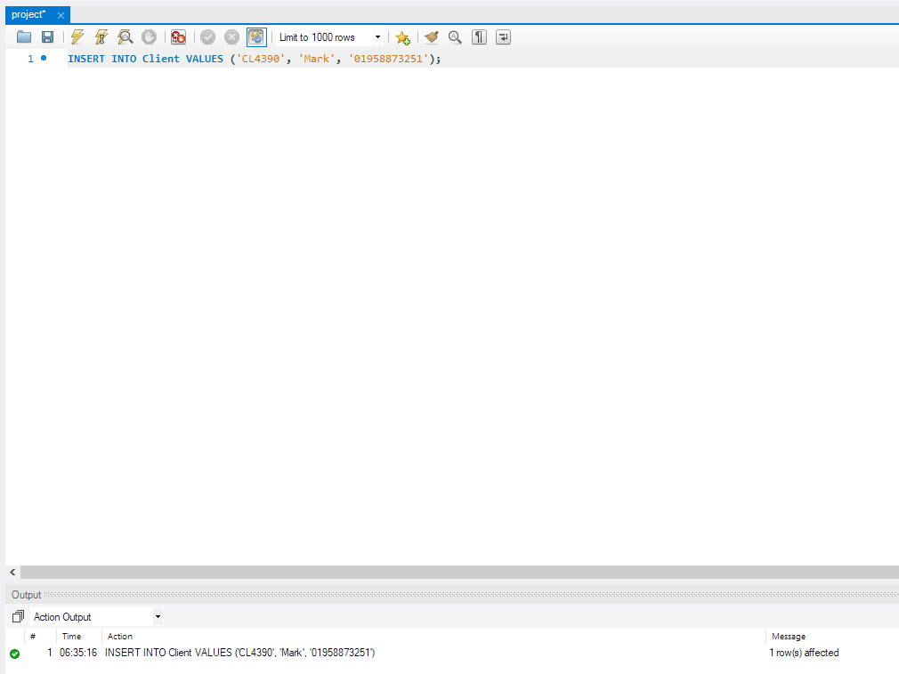
* 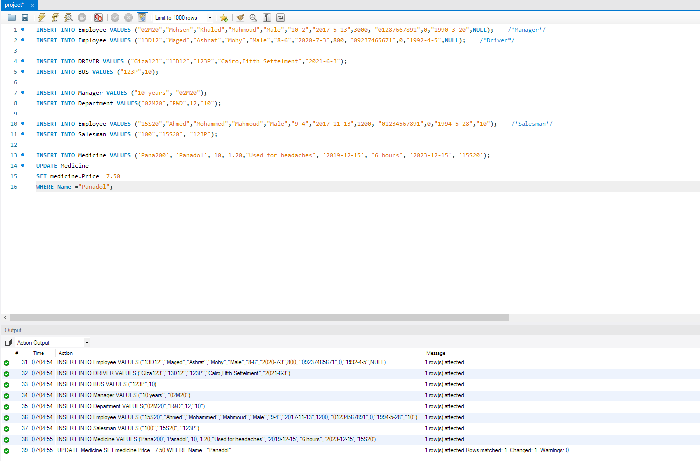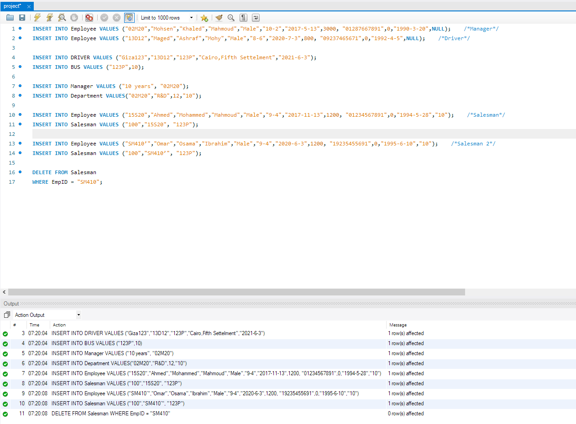**INSERT with (UPDATE , SET , DELETE , and WHERE clauses):**
* 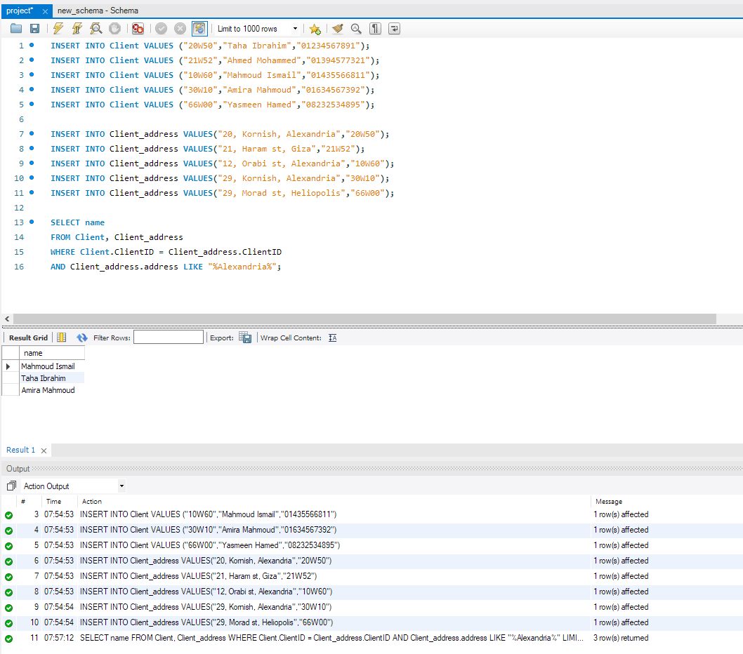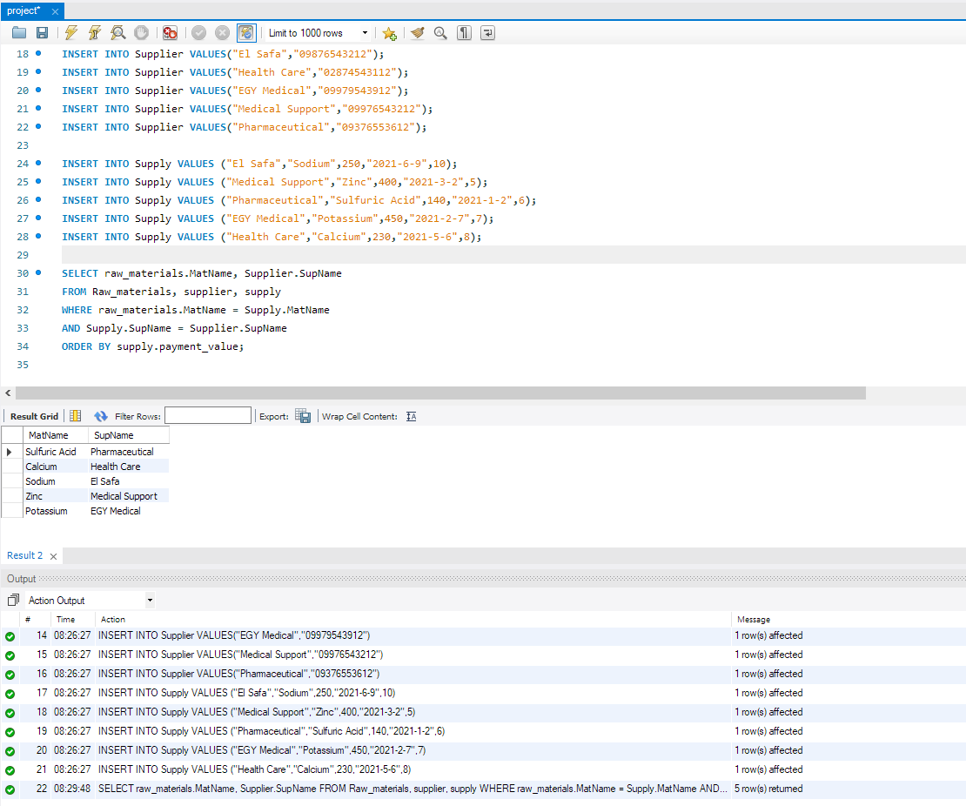**INSERT with (SELECT clause with ORDER BY,WHERE,AND,HAVING Constraints):**

# Implementation

## Using ERD tool

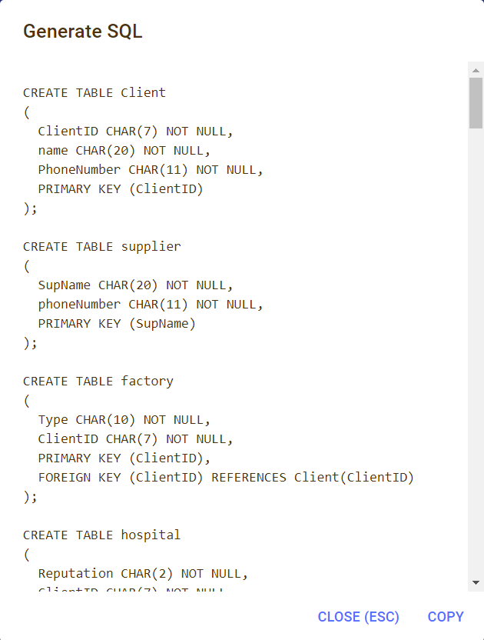

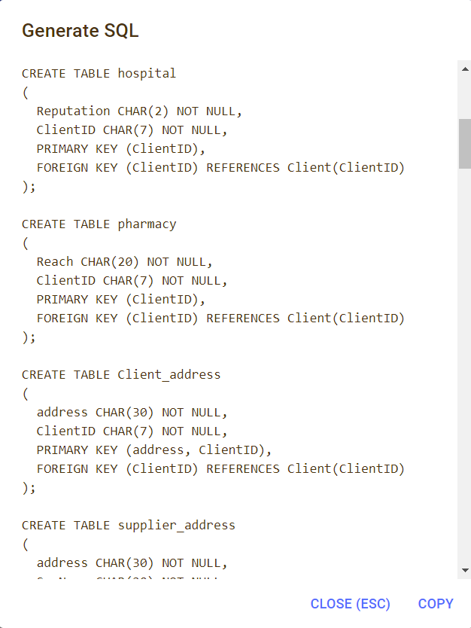

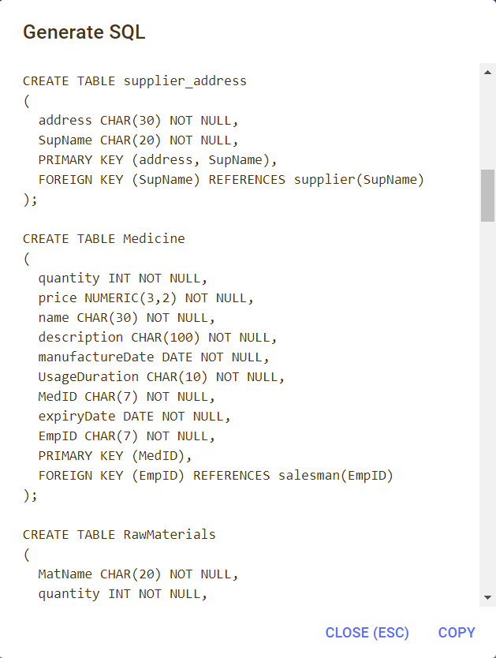

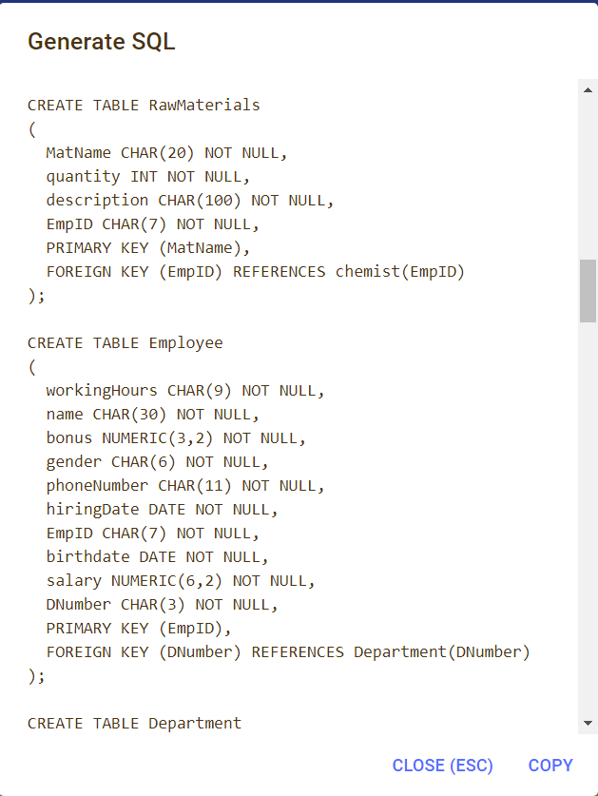

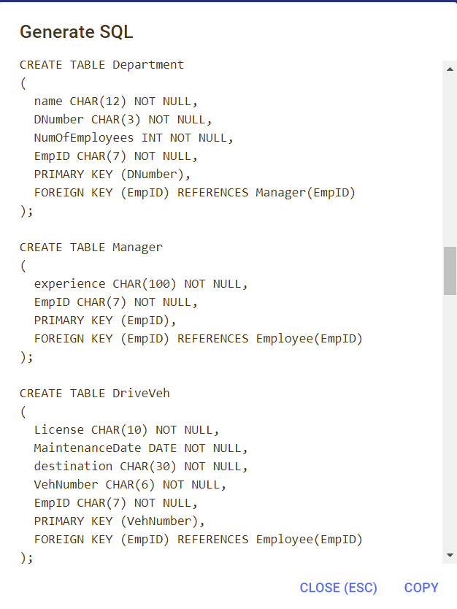

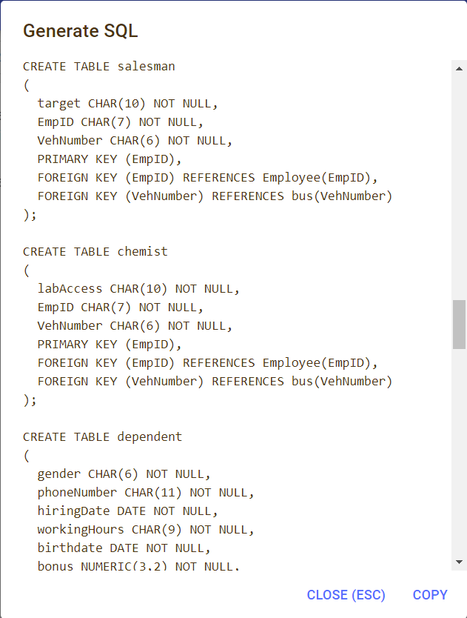

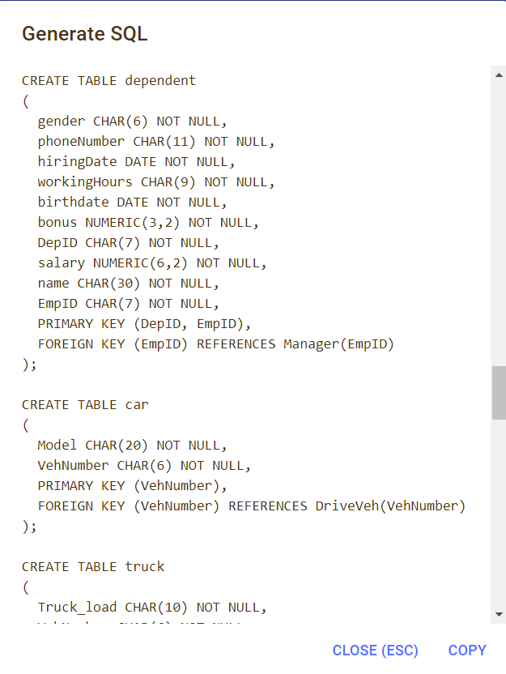

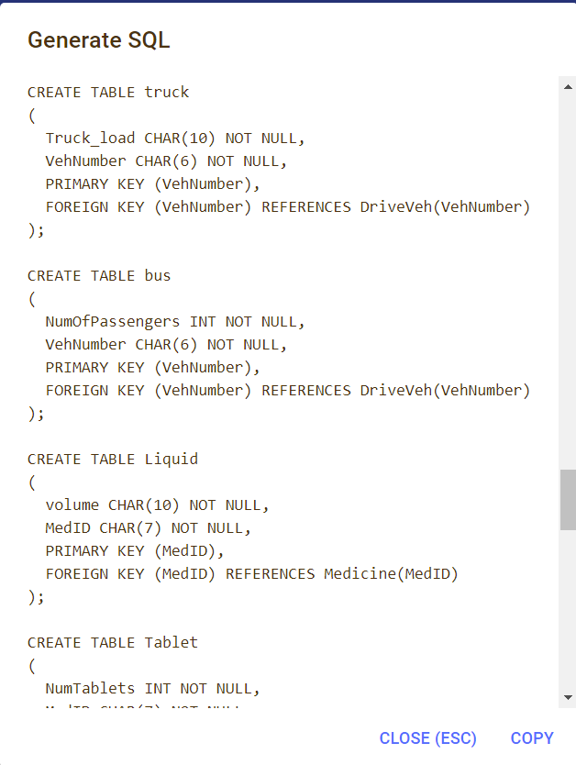

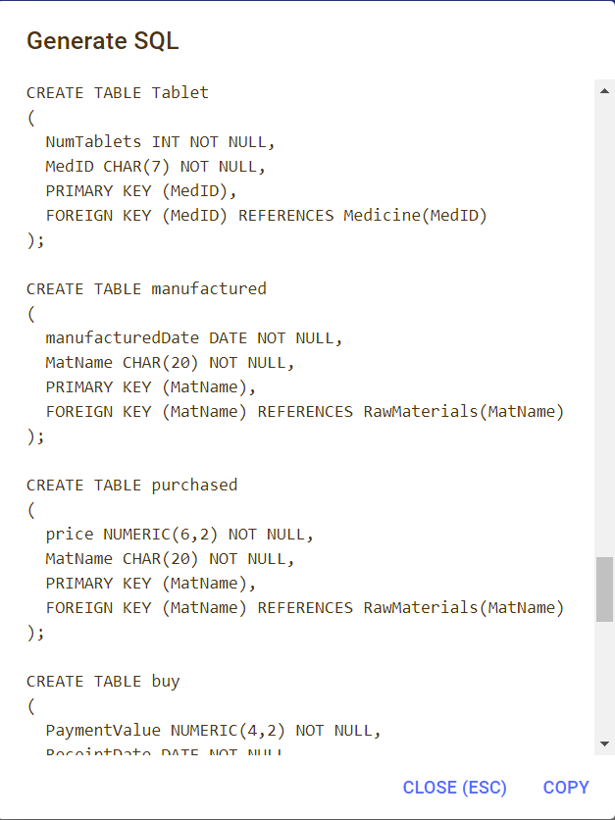

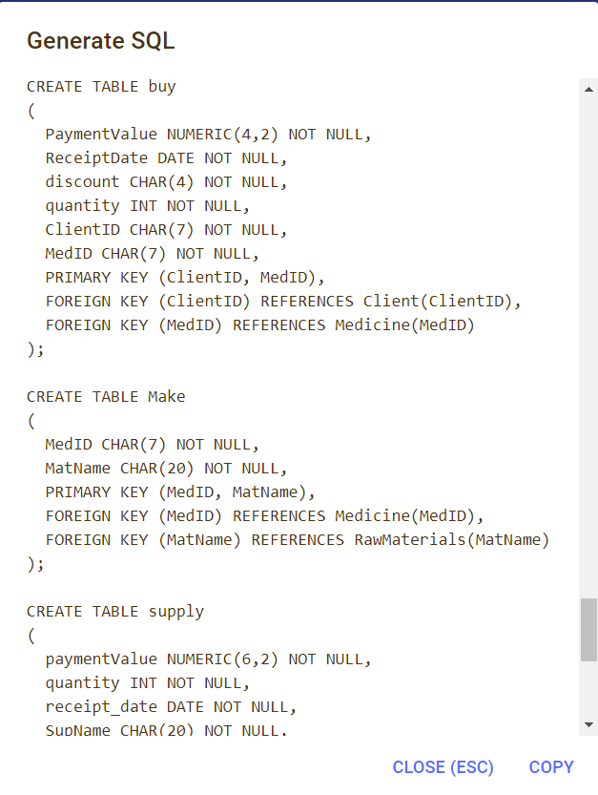

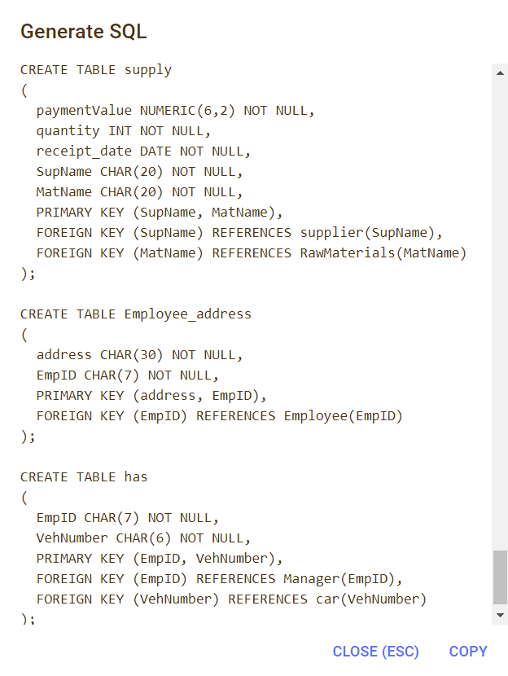

## Using MySQL WorkBench tool